Abilene Christian University
School of Education

Teacher Candidate Handbook

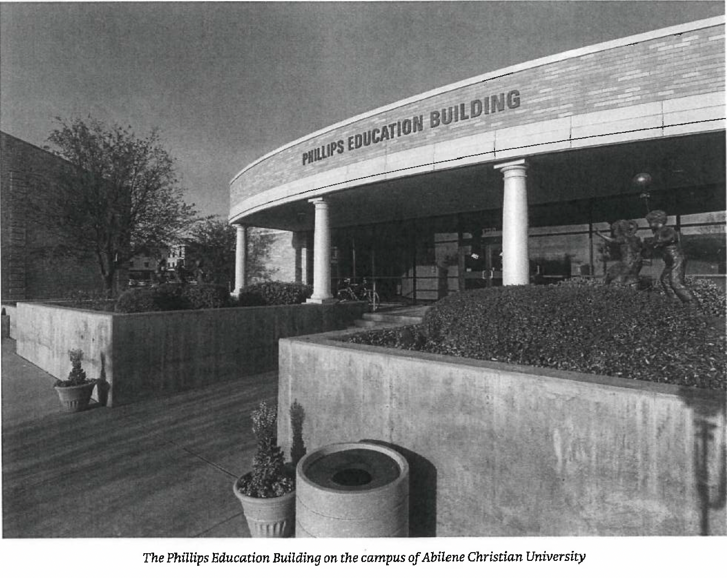

Revised February 2025

Table of Contents

ACU School of Education Mission Statement and Framework 3
Certifications and Degrees Offered 6
Criteria for Admission to ACU School of Education 7
Criteria for Admission to ACU MEd Program 9
ACU Teacher Candidate Dispositions 10
ACU School of Education Exit Process 12
ACU School of Education Re-Application Process 13
ACU School of Education Curriculum Framework 14
ACU School of Education Academic Integrity Policy 15
ACU School of Education Field Placement Dress Code 17
Professional Organizations 18
School of Education Department Course Policies 19
School of Education Capstone Requirements 21
Certification and Testing 22
Clinical Teaching 24 Texas Education Agency Required Disclosures 24
Acknowledgment of Receipt 27

School of Education
Mission Statement
The mission of the School of Education is to prepare exemplary, committed educators for service in diverse and multicultural communities for the glory of God.

ACU School of Education Conceptual Framework

The conceptual framework for ACU’s School of Education communicates our shared vision for preparing excellent professional educators who are aware, reflective, responsive and critical thinkers. It provides direction for our program courses, clinical experiences, assessment, and service. This framework guides our practice and is informed by our faith commitment that teaching is a ministry. As such, we are called to continual personal and professional growth and transformation.

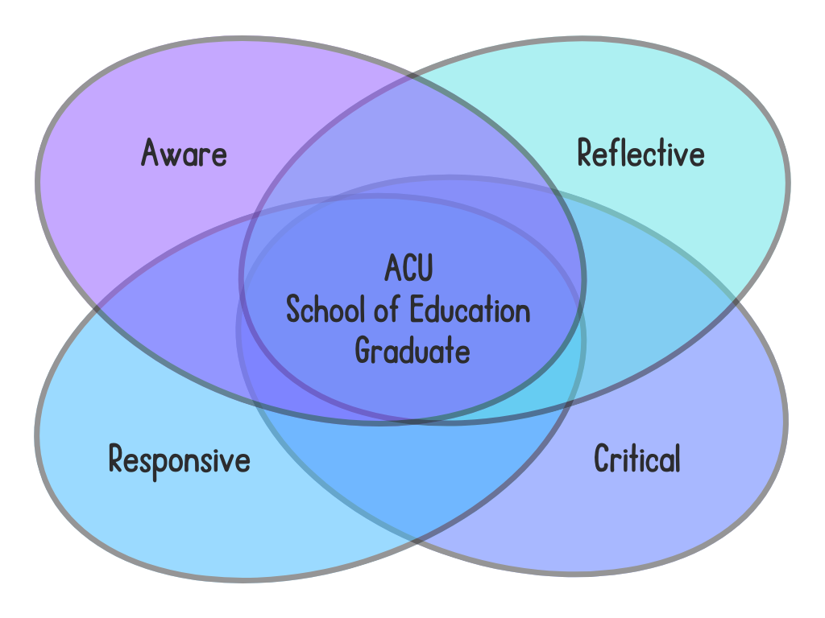
Reflective
Reflection is an active process that involves thoughtful consideration of experiences, learning from those experiences, constructing new knowledge, and applying that new knowledge deliberately to new experiences. Reflection requires courage and is a type of thinking aimed at better understanding. It requires contemplation and honesty while processing thoughts and emotions to explore and explain our world. Reflection allows the identification of positive experiences and ways to continually improve. It helps to identify challenging experiences to learn from them and navigate future challenges. Reflection allows for consideration of different perspectives leading to an improved world for ourselves and others.

Aware
Awareness is a state of consciousness, perception, and cognition of the world around us that is developed through intentional presence. Awareness requires attention directed both inward and outward aimed at deeper understanding of ourselves, others, and the contexts in which we exist. Self awareness requires that we be conscious of our own thoughts, feelings, strengths, weaknesses, and preferences. Social awareness calls us to understand and empathize with the perspectives, needs, and emotions of others, which creates space for community and inclusivity. Globally, awareness brings light to issues, events, and perspectives beyond our own experience. Awareness leads to informed thoughts and actions that build systems up and move them forward.
Responsive
Although the use of a shared curriculum can lead to instructional cohesion and academic achievement (Marzano, 2003), instructional programs alone are not enough to meet the needs of all students. Researchers have demonstrated that teaching is a complex, expert activity, “not amenable to scripted materials, standardized lessons, or any one-size-fits-all plan” (Allington et al., 2002, p. 462). Highly effective teachers use their, “knowledge of students, content, and pedagogy to modify instructional actions in the moment to strategically meet students’ social, linguistic, and instructional needs” (Vaughn et al., 2022, p. 186). Such teacher responsiveness/adaptiveness has been identified by researchers as one of the most defining characteristics of highly effective teachers but also one of the most often ignored. Responsive/adaptive teachers are outstanding “kid watchers” (Goodman, 1978, p. 41). They closely observe and listen to their students. They utilize a variety of formative and summative assessments to monitor student learning and target areas for growth. Although adaptive/responsive teachers may use instructional programs, they never simply just “do” them, nor are they defined by them. They carefully and boldly make adjustments as needed to ensure students master their objectives. Their instruction is student-centered, ongoing, provisional, work-in-progress, never completed, never perfect, but always evolving to better meet the students’ needs.
Allington, R.L., Johnston, P.H., Day, J.P. (2002). Exemplary fourth-grade teachers. Language Arts, 79(6), 462-466.
Goodman, Y. (1978). Kid watching: An alternative to testing. National Elementary Principal, 57(4), 41-45.
Marzano, R.J. (2003). What works in schools: Translating research into action. Association for Supervision and Curriculum Development.
Vaughn, M., Parsons, S.A. & Gallagher, M.A. (2022). Challenging scripted curriculum with adaptive teaching. Educational Researcher, 51(3), 186-196.

Critical
Critical educators “teach against the grain” (Cochran-Smith, 1991) by actively questioning, constructing, and deepening their understandings of the world and their pedagogies. Unafraid of calling into question seemingly commonsensical, long-standing practices, critical teachers interrogate the myriad structures that shape classroom life in order to “grow a compelling future together” and to “embody the just and liberated worlds we long for” (brown, 2017, p. 24). This kind of critical analysis provides a lens by which to make sense of the ongoing process of becoming aware, responsive, and reflective. It works to trace and untangle the dissonance between the ways schooling is and has been and the way schooling could be. Teaching critically means adopting a posture of questioning that is grounded in a deep curiosity about and attention to problems experienced at the level of everyday life–problems of power, equity, control, justice, and harm. Because teaching is complex, inherently political work, critical educators must take seriously their role as transformative intellectuals (Giroux, 1988), eliciting and challenging their prior assumptions in order to pursue a more intentional vision of democratic life. In this way, critical educators notably reject a posture of cynicism or resignation and instead “have the knowledge and courage to struggle in order to make despair unconvincing and hope practical” (p. 128).
brown, a.m. (2017). Emergent strategy: Shaping change, changing worlds. AK Press.
Cochran-Smith, M. (1991). Learning to teach against the grain. Harvard Educational Review, 61(3), 279-310.3
Giroux, H.A. (1988). Teachers as intellectuals: Toward a critical pedagogy of learning. Bergin and Garvey

Certification Degrees Offered

All-Level Certificates(K-12)
Art, All-Level Teaching, BFA (ART-ARTT)
Music - Instrumental Concentration, All-Level Teaching, BM (MTIA)
Music - Vocal Concentration, All-Level Teaching, BM (MTVA)
Journalism/Multimedia with Teacher Certification, BS (JMTC)
Spanish, BA (SPNT)
Theatre, BFA (THEA-THED)
Early Childhood/Elementary Certificates (EC-6)
Early Childhood/Elementary Certification, BS (IDSC)
Special Education with Early Childhood and Elementary, BS (SPEL)
Middle School Certificates (4-8)
Language Arts, BS (MSED-MSLN)
Mathematics, BS (MSED-MSMT)
Science, BS (MSED-MSSC)
Social Studies, BS (MSED-MSSO)
High School Certificates (7-12)
Chemistry Education, BS (CPST-CHMT)
Composite Science - Engineering and Physics, BS (PHMT- PHCS)
Composite Sciences, Life Science BS (BIOT-BTCS)
Composite Science, Chemistry (CPST-CMST)
Life Science, BS (BIOT-BIOT)
Physical Science, BS (CPST-CPST)
English, BA (ENGT)
History, BS (HSTT)
Social Studies, BS (HSST)
Computer Science and Mathematics, BS (CSMT)
Mathematics, BS (MATT)
Physics and Mathematics, BS (PHMT-PHMT)

Criteria for Admission to ACU School of Education

In accordance with Texas state law, the ACU School of Education has established the following criteria for admission to our program. Before taking more than 6 hours of professional education coursework, the student must first be admitted to the School of Education Program. To be admitted to the School of Education Program, a student must meet the following criteria at the time of admission:

- Complete and submit the application for admission into the School of Education Program;
- Have completed the first 45 semester hours of credit;
- Successfully complete with a C or better 15 hours in the candidate’s chosen content field;
- Have a minimum Grade Point Average (GPA) of 2.75 overall and in the chosen content field;
- Complete 6 hours of university required freshman English requirements with no grade lower than a “C” (In order to maintain admission status, the candidate must earn a C or better in all university required English courses.);
- Demonstrate proficiency in the English language, reading, writing, and math through one of the following:

Reading and Writing
- A grade of C or higher in university required freshman English
- ACT English score of 19 or higher
- SAT reading score of 510 or higher
- TSIA2 reading score of 945 or higher
Math:
- A grade of C or higher in MATH 120 or higher
- ACT math score of 19 or higher
- SAT math score of 510 or higher
- TSIA2 math score of 950 or higher

- Successfully complete (C or better) EDUC 211 Introduction to Education: Culture and Contexts;
- Successfully complete the first Teacher Candidate Dispositions Review as described in the ACU Teacher Candidate Handbook;
- Declare a major that includes certification;
- Successfully complete a student life review; and
- Receive approval from the Chair of the School of Education and the Certification Officer. An interview with the Admissions and Review Committee may be required.

Note: Any exemptions or modification to the above requirements due to special circumstances must be requested through the chair of the School of Education. All requests will be reviewed and must be approved by the School of Education Admissions and Review Committee.

English Language Proficiency Assessment Requirement:

All students must demonstrate English language proficiency by successful completion of ACU required freshman English with a grade of C or higher. Additional English language proficiency requirements for international students with primary languages other than English must demonstrate English language proficiency by a TOEFL iBT score of 100 with the following minimum scores in each section:

- Reading – 24
- Listening – 24
- Speaking – 26
- Writing – 24

Note: These scores must be earned in a single administration of the TOEFL.

Additional program requirements:

- To remain in the School of Education Program, an overall GPA of 2.75, a GPA of 2.75 in all professional education courses (EDUC, SPED, READ and EACH) and content field GPA of 2.75 in all ACU coursework
- must be maintained.
- To maintain eligibility, candidates must be able to perform the essential functions of teaching.
- A grade of C or better is required for all courses in the candidate’s teaching field, all professional education courses, and all courses in the major.
- All professional education courses (EDUC, READ, SPED, and EACH) must be taken in residence.
- Any appeals related to admission will be directed first to the Chair of the School of Education. If the candidate does not feel the issue is resolved, the appeal will be forwarded to the Dean of the College of Arts, Humanities and Social Sciences.
- You may retake a professional education course (EDUC, READ, SPED, and EACH) ONE time if needed.

Note: A candidate who does not have an overall GPA of 2.75 or higher may be admitted to the program if all other admissions criteria are met and if all of the following are true:
- An overall GPA of 2.75 or higher in the last 60 hours or an overall GPA of 2.75 or higher in courses that fulfill the declared certification degree
- A GPA of 2.75 in the teaching content field with no grade lower than a C
- No university disciplinary actions filed – academic or otherwise
- A formal letter of request submitted to the School of Education Admissions Committee describing the candidate’s academic history and articulating motivations for wanting to enter the teaching profession
- An interview with the School of Education Admissions Committee.

Admission to the M.Ed. in Teaching and Learning:

To qualify for the M.Ed. In Teaching and Learning, candidates must have a declared undergraduate ACU degree that includes certification and must be currently admitted to the ACU undergraduate Teacher Education Program.Candidates apply to the M.Ed. Teaching and Learning program in the fall of the junior year and are admitted to the program in the spring of the junior year. To be admitted to the M.Ed. in Teaching and Learning program, applicants must

- A minimum cumulative GPA of 3.0
- A minimum content field GPA of 3.0
- No grade lower than B in any Professional Education Courses (EDUC, READ, EACH, SPED)
- Three Dispositions Reviews (Faculty References) with no score below a 3
- Completed Application with a Statement of Purpose and Philosophy

To remain in the M.Ed. program candidates must maintain the overall GPA of 3.0 in undergraduate courses with no grades lower than a B in any professional education or content field courses. Candidates will enroll in the first six hours of the graduate sequence in the spring of the senior year and will complete Clinical Teaching during the master’s year.

Admission to the Post-Baccalaureate Certification Route:

Admission to the post-baccalaureate certification track includes the following:
- Admitted in good standing in the M.Ed. in Teaching and Learning
- Completion of all professional education (EDUC, EACH, READ, or SPED) coursework in the designated undergraduate certification degree (with the exclusion of EDUC 490 Clinical Teaching) with a B or higher.
- An overall GPA of 3.0.
- No grade lower than a B in the designated content field.
- A Dispositions Review administered by the professor of the appropriate undergraduate capstone course (during EDUC 411/431 Elementary Block, EDUC 412/432 Secondary Block or MUSE 449 Professional Practice in Music Education) with a no score lower than a 3.

Additional information for international students:

As part of your professional preparation, you will be participating in various field experiences. The tasks performed in these experiences may be considered “work” from an immigration standpoint. Therefore, all non-U.S. citizens are advised to obtain the proper work permission before any field experience begins. F-1 and J-1 international students should consult the immigration specialist in the Center for International Education concerning work authorization procedures as soon as possible.

Formative Assessment of GPA and Dispositions

At the end of each semester throughout the program, our Certification Officer will audit each candidate’s overall GPA, professional education course GPA, and content field GPA. If the GPA (overall, professional education or content field) has dropped below 2.75, admission to the program will be revoked. Candidates whose admission status is revoked will be notified within two weeks of the audit.

If admission is revoked because of failure to meet the GPA requirements, the candidate must re-apply to the program and meet the standards at the time of reapplication. If admission is revoked a second time, the candidate will not qualify for readmission and must declare a new major. Additionally, if courses need to be retaken in order to meet GPA requirements, courses with prefixes of EDUC, EACH, SPED, READ may only be retaken once.

All teacher candidates undergo four formal reviews throughout the ACU School of Education Program. These reviews include assessment of the candidate’s dispositions for the teaching profession. Candidates must also understand that at any point in the program a Dispositions Review may be completed by any instructor, advisor, supervisor, Student Life administrator or field placement cooperating teacher. If concerns are identified, a meeting with the Teacher Education Admissions Committee may be scheduled with the candidate to discuss any potential implications for the candidate’s admission status. A score of 1 in any area of the Dispositions Review may result in the removal from the Teacher Education Program.

ACU Teacher Candidate Dispositions Benchmarks

Formal Review 1: Admission to Program
- Cut score - 65
- Any score of 1 will result in a meeting and a growth plan with next steps.
Formal Review 2: READ 322 or EDUC 370
- Cut score - 70
- Any score of 1 will result in a meeting and a growth plan with next steps..
Formal Review 3: Admission to Clinical Teaching
- Cut score - 75
- Any score of 2 or below will result in a meeting and a growth plan with next steps.
Formal Review: Clinical Teaching
- Cut score - 85
- Any score of 2 or below will result in a meeting and a growth plan with next steps.

ACU Teacher Candidate Dispositions
PRE-CLINICAL RUBRIC
CLINICAL TEACHING RUBRIC
M.Ed. RUBRIC

Effective Communication |  | Emotional Maturity
- Oral Expression  - Written Expression  - Tact/Judgement  - Interaction with Peers |  | - Reliability/Dependability  - Self-Initiative/Independence  - Conflict Management  - Flexibility  - Emotional Constancy
Reflective Practice |  | Integrity
- Response to Feedback  - Personal Reflection  - Problem Solving  - Self-Efficacy |  | - Integrity of Speech  - Ethical Behavior
Professionalism
- Attendance
- Punctuality
- Personal Appearance
- Values Learning
- Collegiality
- Sensitivity and Awareness
- Acceptance

Additional Dispositions for Clinical Teaching: Professional Responsibility
- Diligence in Documentation and Planning
- Commitment to Professional Growth
Additional Dispositions for the M.Ed. Application: Scholarship
- Intellectual Curiosity
- Deep and Thorough Preparation
- Independence of Thought
- Academic Language

Exit Process
Exit Policy for Certification Programs
The state requires all educator preparation programs to have an exit policy for the dismissal of candidates that is published, reviewed and signed by candidates when they are admitted to the program. The requirement is found in section 228.20 of the Texas Administrative Code.
Dismissal from the School of Education
Initial and professional certification candidates may be removed from ACU’s Educator Preparation Program (EPP) when candidates demonstrate behavior inconsistent with the knowledge, skills, and dispositions expected of teachers in Texas and students at Abilene Christian University. Dismissal from the program may be based on the grounds including but not limited to:
1. Failure to meet the coursework requirements.
2. Failure to abide by policies and/or procedures established by the ACU School of Education and/or program requirements established by the State Board of Educator Certification as published in the Texas Administrative Code (TAC) and the ACU School of Education Handbook.
3. Failure to meet the requirements of ACU’s School of Education Dispositions Reviews Policies. (See p. 10 of this handbook .)
4. Any action deemed to a violation of the Code of Ethics and Standard Practices for Texas Educators, and/or;
5. Any action deemed a violation of the Abilene Christian University’s Student Code of Conduct and/or;
6. Any action deemed a violation of school district and/or campus policy during field-based experiences, clinical teaching, internship and or practicum.
Dismissal from the program is determined by a committee of the program faculty. Dismissal may occur at any time. Candidates who are dismissed from the Abilene Christian University School of Education will be automatically dismissed from the EPP. All decisions can be appealed following the University policies. Withdrawal from the University constitutes an automatic withdrawal from the EPP.

Withdrawal from the School of Education
If a candidate chooses to withdraw from the School of Education for any reason, the Registrar's Office or the advisor will contact the School of Education. This will result in being removed from not only the School of Education, but also the EPP.
Students are considered to be inactive in the School of Education when they are no longer completing coursework, training and testing requirements for two consecutive semesters. At this point, the inactive candidate will be removed from both the School of Education as well as the EPP.
If a candidate chooses to enroll in a different EPP, the receiving program will need to request a Texas Education Agency (TEA) Texas Education Transfer Form to be completed by the certification officer. At that time, the certification officer will be required to inform the receiving program if the candidate was in good standing.

Re-Application Process
If a candidate is removed from ACU’s EPP, either voluntarily or involuntarily, and desires to reapply for the following school year, that candidate should do the following:
1. Ensure that they meet the admission requirements, and
2. Complete a new application to ACU’s School of Education, and
3. Meet with the Chair of the School of Education.
A committee of the program faculty will meet to review the evidence to evaluate whether or not accessibility to the School of Education and ACU’s EPP is granted. Once a decision has been made regarding the candidate’s eligibility to re-enter ACU’s EPP, that student will be notified via email from the Chair of the School of Education.
NOTE: You may only be re-admitted to ACU’s EPP one time after dismissal.

ACU School of Education Curriculum Framework

The curriculum of the ACU School of Education is aligned with the Texas Teacher Standards. The Texas Teacher Standards are accessible HERE.

Standard 1: Instructional Planning and Delivery
Teachers demonstrate understanding of instructional planning and delivery by providing standards-based, data-driven, differentiated instruction that engages students, makes appropriate use of technology and makes learning relevant for today’s learners.
Standard 2: Knowledge of Students and Student Learning
Teachers work to ensure high levels of learning, social-emotional development, and achievement outcomes for all students, taking into consideration each student's educational and developmental backgrounds and focusing on each student's needs.
Standard 3: Content Knowledge and Expertise
Teachers exhibit a comprehensive understanding of their content, discipline, and related pedagogy as demonstrated through the quality of the design and execution of lessons and their ability to match objectives and activities to relevant state standards.
Standard 4: Learning Environment
Teachers interact with students in respectful ways at all times, maintaining a physically and emotionally safe, supportive learning environment that is characterized by efficient and effective routines, clear expectations for student behavior, and organization that maximizes student learning.
Standard 5: Data-Driven Practices
Teachers use formal and informal methods to assess student growth aligned to instructional goals and course objectives and regularly review and analyze multiple sources of data to measure student progress and adjust instructional strategies and content delivery as needed.
Standard 6: Professional Practices and Responsibilities
Teachers consistently hold themselves to a high standard for individual development, collaborate with other educational professionals, communicate regularly with stakeholders, maintain professional relationships, comply with all campus and school district policies, and conduct themselves ethically and with integrity.

In alignment with the Christian mission of ACU, we have added the following standard:

Standard 7: Christian Hospitality and Professional Practice
ACU teacher candidates reflect on how the Christian virtue of hospitality supports inclusive professional practices

Academic Integrity and Professional/Ethical Conduct

ACU SChool of Education Policy and Guidelines

The School of Education at Abilene Christian University is committed to integrity and ethical conduct. It is the responsibility of faculty, staff and students to honor Christian and professional ethical principles including, but not limited to, academic integrity, honesty, and caring. Students and faculty have the right to expect their work to be assessed on its academic merit. All faculty, staff, and students are expected to espouse academic honesty and every individual is responsible for upholding this expectation. Ethical and honest behavior is required in all actions that support the Teacher Education Program’s academic mission. This is also informed by the ethical expectations outlined by the Texas State Board for Educator Certification in the Code of Ethics and Standard Practices for Texas Educators linked here.

Finally, our Christian commitment calls us to the highest standards of ethical behavior and integrity.

Examples of possible breaches in ethics or integrity include, but are not limited to:

- Submitting another's work as one's own or allowing another to submit one's work as though it were his or hers
- Several people completing an assignment and turning in multiple copies, all represented either implicitly or explicitly as individual work
- Failure to properly acknowledge authorities quoted, cited or consulted in the preparation of written work (plagiarism)
- The use of a textbook or notes during an examination without permission of the instructor
- The receiving or giving of unauthorized help on assignments or exams
- Stealing a problem solution from an instructor
- Lying about any academic matters
- Chapel integrity violations
- Falsifying college records, field placement documentation, field placement evaluations and/or professional development points documentation
- Sexual misconduct with students
- Viewing pornography at school or with school computers
- Illegal use of drugs or alcohol
- Promoting alcohol or illegal drug use with students
- Failure to accept reasonable direction from the cooperating teacher, university supervising teacher, the director of Clinical Teaching and/or the department chair
- Other offenses that are serious ethical violations as described in The Code of Ethics and Standard Practices for Texas Educators
- Serious violations of school district policies and regulations in the field placement district

Procedure:

If a faculty member believes that a violation of integrity has been committed, the procedure outlined in the Abilene Christian University Student Integrity Policy will be followed to determine whether a breach of integrity has occurred. This procedure can be found in the ACU Student Handbook. If it is determined that an integrity violation has been committed the following consequences will apply.

First Offense:
If it is confirmed that a student committed an integrity offense described in items 1-8 above, the first offense will result in the following consequences:

- The student will receive a grade of zero on all relevant assignments and/or exams.
- The student will meet with the faculty member(s) and the chair and submit a formal written response, addressing lessons learned and describing personal and professional implications of the integrity breach.
- A “Formal Review of Concern” will be filed in the candidate’s Admission and Review folder.
- The violation will be reported to the Dean of Students at the conclusion of the departmental process.

Note: Any first integrity offense included in the description in items 9 - 16 above will result in dismissal from the School of Education. In addition, any integrity breach committed during Clinical Teaching that is directly related to the Clinical Teaching placement and/or requirements will result in automatic removal from Clinical Teaching and a failing grade will be assigned.

Second Offense:
Any confirmed second breach of integrity as described in numbers 1-8 above will result in dismissal from the School of Education. It is understood that a total of two integrity breaches, rather than two offenses in each category, will result in dismissal from the School of Education. A breach of integrity may be reported to the Chair of the School of Education by any official ACU faculty or staff member in a position of authority over the teacher candidate including but not limited to course instructors, field experience cooperating classroom teachers, and student life personnel. If the integrity breach occurred in the context of a professional education course, in addition to departmental procedures, the violation will be reported to the Dean of Students.

Appeals:
The process for appeals is also outlined in the ACU Academic Integrity and Honesty Policy - https://acu.edu/office-of-the-provost/academic-policies/ .

Field Placement Dress Code

At all times the candidate is expected to meet district and campus expectations regarding dress code. These expectations vary from district to district and reflect the culture of the community. The following specific guidelines for the ACU School of Education candidates have been developed to reflect area district expectations:

- A district badge must be worn on any campus during every field experience placement through graduation. ACU lanyards are available through the Teacher Education office.
- Appropriate, professional and modest attire is required. Spaghetti straps or strapless tops are considered unprofessional. Necklines must be appropriately modest and avoid revealing cleavage. Any exposure of midriffs or backs is unprofessional. Tops worn over leggings must be of appropriate length, following district policy.
- Clothing must be appropriately sized. Clothing that is excessively altered, slit, worn, or frayed is not professional.
- Shorts of any length are unacceptable unless serving in a physical education or athletic capacity.
- All apparel and/or accessories must be free of references to race, alcohol products, tobacco products, drugs, sex, vulgarity, death, suicide, or violence either explicitly or by innuendo.
- Shoes appropriate for school must be worn at all times. Beach shoes are considered unprofessional.
- Any apparel or accessory that denotes gang-related association is prohibited, i.e. rags, bandanas, chains, spiked or studded items, or other physical alterations as identified by local law enforcement.

In the case where the district has established standards that go beyond those outlined here, candidates are required to abide by the district policy. If the district is more lenient, our students are required to abide by the policies outlined in this document.

Professional Organizations

Membership in professional education organizations has many benefits, which may include liability insurance at no cost or reduced rates, access to professional literature, and professional development opportunities. As part of the School of Education at ACU, candidates are expected to explore these organizations and join and maintain membership in at least one professional organization. There are many organizations that may meet this requirement. A partial list of organizations can be found below.

State Teacher Organizations:
These organizations provide liability insurance for the pre-service and/or in-service teacher.
  - Association of Texas Professional Educators; http://www.atpe.org
  - Texas Classroom Teachers Association; http://tcta.org
  - Texas State Teachers Association; http://www.tsta.org

National Organizations by Teaching Field:
These organizations are devoted to a particular age level or content field. We strongly recommend that you maintain an active membership in one or more professional organizations directly related to your teaching field. These organizations provide publications, conferences, and other professional development opportunities to support your continued development as a professional educator.

  - National Council of Teachers of English; http://www.ncte.org
  - International Reading Association; http://www.reading.org
  - National Council of Teachers of Mathematics; http://www.nctm.org
  - Council for Exceptional Children; http://cec.sped.org
  - National Association for the Education of Young Children; http://www.naeyc.org
  - National Art Education Association; https://www.arteducators.org
  - National Science Teachers Association; http://www.nsta.org
  - National Council for Social Studies; http://www.socialstudies.org
  - American Alliance for Theatre and Education; http://www.aate.com
  - National Association for Music Education; http://www.nafme.org
  - Christian Educator Association International; http://www.ceai.org/
  - Association for Childhood Education International; http://www.acei.org/
  - National Middle School Association; http://www.nmsa.org/

Teacher Education Department Course Policies

Course Grading Policies
The School of Education is committed to high academic standards. In keeping with this commitment, the department has chosen to utilize the following grading scale:

A 90-100
B 80-89
C 70-79
D 60-69
F 59 and below

Course grades will reflect the candidate’s mastery of the course competencies as aligned with the Texas Teacher Standards.

It is departmental policy not to provide extra credit assignments. An instructor may, however, find it appropriate for a student or students to be given the opportunity to resubmit an assignment in order to demonstrate competency. In these cases, the instructor will communicate clearly how this may impact the assigned grade.

All assignments must be completed in a course in order to qualify for a C or better in the course. The syllabus will identify course policies for late submission of assignments.
Course grades cannot be changed after grades are recorded at the end of the semester except in the case of instructor error.

Mastery Assignments
In each course, the syllabus will identify mastery assignments. Successful completion of these assignments is necessary to demonstrate appropriate mastery of course objectives. To earn a C or better in the course, these assignments must be completed at a mastery level consistent with a grade of C or better.

Candidates will be provided one opportunity for resubmission of identified mastery assignments if the appropriate level of mastery is not met. If upon resubmission the candidate demonstrates a mastery level of C or better, a course grade of C or better is possible. If the resubmission does not meet mastery level of C or better, the highest grade possible in the course will be a D. While successful resubmissions of mastery assignments qualify the candidate for a grade of C or better in the course, the assignment grade does not change. The original score earned is what will be reflected in the grade book.

If the final exam has been designated as an official mastery assignment, there will be no opportunity to retake the exam. The grade earned will determine successful completion of the course.

Attendance Policy
In their syllabi, each professor will clearly establish attendance criteria for their course. Additionally, as a professional licensing program, we are required by the Texas Education Agency to demonstrate students’ completion of the necessary content for teacher certification. For this reason, if a student in the School of Education misses more than three weeks of class, the student will be dropped from the class. In extenuating circumstances where communication has been clear, exceptions may be considered.

Writing Standards
The field of education uses the American Psychological Association (APA) standards for writing. Therefore, within courses in the School of Education, students are expected to utilize APA format for all formal writing assignments. The APA manual is available in the library and citation support tools are available on the ACU Library webpage.

Furthermore, as students in a professional program it is expected that care will be given in all written communication. Accurate use of grammar and spelling is always important. It is advised that students use professionalism in written communication in e-mails as well.

Incomplete Policy
An incomplete may be granted if a teacher candidate has not met the requirements of the course due to extreme situations outside the candidate's control. An incomplete is not given when a student has simply been negligent toward class requirements. An "I" can only be assigned with the Instructor’s permission if the candidate has completed at least 75% of the course in good standing. An “I” is removed by the completion of the necessary work within the next long term at a time approved in writing by the instructor, otherwise the “I” will become an “F” on the student’s record. It is not possible to change the grade after the “F” is recorded. If it is determined that an "I" is the best option, an Incomplete Policy Contract will be signed by the candidate and the instructor and be filed with the University and a copy will be placed in the Admission and Candidacy File in the Certification Office.
Audit Policy
The Teacher Education Department does not permit individuals to audit courses in Professional Education. This includes all courses with the following prefixes: EDUC, EACH, READ and SPED.

Transfer Policy
Both state and national policy hold us accountable for your preparation. For this reason, it is not possible to transfer in professional education coursework from another institution. All professional education courses (EDUC, READ, SPED and EACH) must be taken in residence.

Courses not in professional education that are transferred from other colleges and universities may fulfill general degree plan requirements. This will be determined by stated university policy or by the individual ACU content field department. However, while credit for the course may be granted, the grades from transferred courses will not be included in GPA calculations for purposes of initial or continuing admission to the ACU School of Education.

Teacher Education Capstone Requirements

The ACU School of Education Capstone requirements are completed in EDUC 411/431 Elementary Block, EDUC 412/432 Secondary Block or MUSE 449 Professional Practice in Music Education.

Capstone Paper: Professional Goals

The block classes listed above serve as the designated writing-intensive course for education majors. Writing-intensive courses emphasize writing as a primary mode of learning, and written assignments constitute much of the final grade. Adopting language from the ACU Catalog, writing-intensive courses contribute to students’ “strong analytical, communication, quantitative, and information skills - achieved and demonstrated through learning in a range of fields, settings and media, and through advanced studies in one or more areas of concentration.”

ACU School of Education Capstone Field Experiences

August Experience

The August Experience is required of all education majors in the final fall of their professional preparation coursework. August Experience is required in compliance with the Texas Administrative Code requirement that all teacher candidates in Texas participate in a first-of-school experience. In the final fall of your program preparation, you will return to the ACU campus at least one week prior to the beginning of the AISD school year. This is typically a minimum of two weeks prior to the first day of classes at ACU. Final dates are provided when the local school district calendar is established.

During August Experience candidates participate in state-mandated professional development, spend two to three days on a local campus assisting their assigned mentor teacher in preparation for the first day of school and spend the first two days of school in the assigned classroom. Be aware of the timing of August Experience as you make summer plans before your final fall. There are no excused absences for August Experience with the exception of a major personal or family crisis such an illness or death. In these cases, an alternative assignment will be required.

Senior Showcase

You will select artifacts from your professional preparation during Clinical Teaching for the first five of the Texas Teacher Standards and for the additional ACU standard on Christian Hospitality and Professional Practice. *Standard 6 is not included in the Showcase Presentation.

Certification and Testing

Teacher Certification:

Candidates seeking certification will be expected to meet the requirements in admissions policies, program policies, and certification that are in effect at the time they graduate even if they are different from those in the catalog in effect upon enrollment. These changes may be necessary in responses to changes in policy at the state level. Candidates will be informed of changes when they occur. Every appropriate effort will be made to substitute courses for students if requirements change while continuing to prepare candidates for successful completion of the program.

To be eligible for certification through ACU School of Education, all initial certification exams must be passed no later than the graduation date of the semester of clinical teaching.

TExES Certification Exam Preparation and Registration Process:

All program candidates must pass the TExES Pedagogy and Professional Responsibilities exam and the TExES content exams for the appropriate teaching fields as required by the Texas Education Agency (TEA). Candidates must pass the relevant content TExES and the TExES PPR prior to admission to Clinical Teaching. Candidates must be approved by the ACU School of Education for each relevant certification exam. The ACU School of Education makes every effort to have available all published official practice forms of the TExES to assist candidates in their preparation. Testing costs are the responsibility of the teacher candidate and occasionally increase. The ACU School of Education will inform teacher candidates of current costs and make every effort to inform them of fee increases. Information about and registration for the TExES exams is available at the following:
http://www.tx.nesinc.com/PageView.aspx?f=GEN_Tests.html

All ACU teacher candidates are prepared for the ESL Supplemental TExES. The ESL certification may be required by school districts; therefore, be prepared to take this TExES prior to graduation. If you wait to add the certification after you are certified, you will pay an additional fee to add this or any other certification to your certificate. We strongly recommend that candidates complete this exam prior to applying for initial certification.

Limit on Retakes:
State law allows a total of 5 attempts at any one TExES certification exam.

Retake Policy for EC-6 Certifications:
If you do not pass the entire Core Subjects TExES the first time, each attempt on the exam counts as one of your 5 allowed tests, even if you only register for one of the subject exams. Therefore, it will almost always be best to take any portions that you need to pass at one time.

Certification through the Texas Education Agency (TEA):

To be recommended for certification by ACU candidates must:
- Complete Clinical Teaching with a B or higher.
- Successfully complete all requirements as outlined in the ACU Catalog and the School of Education Handbook.
- Have the final degree posted by the ACU Registrar’s Office.
- Pass all required TExES exams.
- Apply for certification through TEA. (This includes fees assessed by the State of Texas.)

Additional certifications can be secured directly through the Texas Education Agency through certification by examination only after earning the initial certification(s) for which you have been prepared by the ACU School of Education.

National Criminal History Checks -- FAQs
TEA conducts a national criminal history check on all applicants for certification. Texas Education Code (TEC) §22.0831 states "The board shall review the national criminal history record information of a person who has not previously submitted fingerprints to the department or been subject to a national criminal history record information review." This must be completed prior to admission to Clinical Teaching. More information about this process is available on the Texas Education Agency website at the link below.
https://tea.texas.gov/texas-educators/investigations/national-criminal-history-checks-faqs

Preliminary Criminal History Evaluation – FAQs
Candidates may request a preliminary criminal history check if they are concerned about their personal history and its potential impact on eligibility for teacher certification. Further information about this process is available on the Texas Education Agency website at the link below.
https://tea.texas.gov/texas-educators/investigations/preliminary-criminal-history-evaluation-faqs

Clinical Teaching

Teacher preparation is a full semester commitment (490 hours minimum required by the Texas Administrative Code ). Clinical Teaching experience as required by the State of Texas for teacher certification. M.Ed. candidates complete two semesters of Clinical Teaching. Once accepted into Clinical Teaching, candidates are assigned to cooperating teachers in the appropriate level and subject area of their intended certification(s) and work directly under the supervision of the classroom mentor teacher(s).

Clinical Teachers are expected to gradually assume the full responsibilities of classroom instruction. These responsibilities include planning and presenting lessons, allowing for individual differences in students, maintaining classroom management, maintaining a comfortable learning environment, establishing a positive rapport with the class, establishing a professional relationship with school personnel, and managing student files and information.

It is important to recognize that this is a university course and will include tasks and reflective assignments in addition to responsibilities in the assigned classroom. These assignments will be outlined in the Clinical Teaching syllabus. As indicated in the ACU Academic Catalog, no additional coursework may be taken along with Clinical Teaching. In addition, it is not possible to compete as an athlete or participate in other university activities that will result in absences (full day or partial day) from Clinical Teaching during this semester.

A field supervisor will be assigned to each Clinical Teacher. Supervisors assess all course assignments and will schedule regular observations and evaluation sessions.

Clinical Teaching includes weekly seminar meetings every Tuesday from 4:00-6:00 p.m. These seminars are a required component necessary to satisfy course requirements.

Texas Education Agency Required Disclosures

Program Closure Procedures:
Abilene Christian University is committed to the School of Education and has been preparing teachers since 1922. Still, as required by TEA, ACU has established the following process if at any time we are closing any certification area:

- All candidates in the program will be notified with the closing date via their ACU email account.
- All candidates who are continuously enrolled in the ACU School of Education will be allowed to complete their program in the normal time frame for their degree plan.
- Candidates will be given copies of their records if they will need to transfer to another program (observation records, etc.)
- ACU will sign a Candidate Transfer Form if you choose to transfer to another program.

Abilene Christian University Educator Preparation Program
Complaint Policy
In compliance with state policy and in consistency with our Christian commitment to excellence and accountability, we are providing the contact information for feedback or any complaints that could arise regarding our program. In addition, links to the Texas Education Agency complaint process and the ACU Student Complaint processes are included below.

Dr. Stephanie Talley
Teacher Education Program Director
Phillips Education Building Room 101
ACU Box 29008
Abilene, TX 79699-9008
Email: stephanie.talley@acu.edu
Phone: 325-674-2112
Dr. Rachael Milligan
Dean of the College of Arts, Humanities and Social Sciences
Phillips Education Building Room 103
ACU Box 28276
Abilene, TX 79699
Email: rhm24a@acu.edu
Phone: 325-674-2700

ACU Student Complaint Policy
https://www.acu.edu/dean-of-students/student-handbook/student-complaint-policy/

Texas Education Agency Complaint Policy
https://tea.texas.gov/texas-educators/preparation-and-continuing-education/complaints-against-educator-preparation-programs

Supply and Demand for Educators in Texas

Note: The following information has been provided by the Texas Education Agency for compliance purposes only. No endorsement of the information sources is implied.

Over the next decade, there will be an increasing demand for new teachers due in part to a dramatic increase in enrollments and high attrition rates as an aging teacher workforce becomes eligible for retirement.

As hiring trends soar, Texas has once again broken its own record by achieving record- breaking hiring in 2013 with over 4,500 new teachers placed in the classroom.

As demographics change in Texas, there will be an increasing need to attract minority teachers. One of the goals of the SBOE is to have a teacher workforce that reflects the racial- ethnic composition of the state.

In the State of Texas, there continues to be a shortage of secondary math and science teachers. The Texas Education Agency has released the statewide teacher shortages areas: Bilingual Education/English as a Second Language; Foreign Languages; Mathematics (STEM); Science; Special Education.

The Texas Workforce Commission anticipates elementary school teaching positions will add the second-highest number of jobs among all occupations in the state through the end of the decade assuming the economy returns to long-term growth patterns. That's nearly 68,000 new jobs. Middle schools are expected to add an additional 65,000 teaching jobs during the same time period.

Typically, teachers are in demand for urban and rural areas. Urban and poor communities will have the greatest need for teachers, with more than 700,000 additional teachers needed in the next decade. Urban communities also face the added challenge of retaining their teachers, who may be attracted to the higher salaries offered in wealthier suburban school districts. The urban schools typically open schools with substitutes in the classroom because of the lack of available certified teachers. Some school districts will pay a signing bonus or extra stipend as an incentive if the teacher agrees to teach in an inner-city school or in a shortage area. If a teacher is trying to get a job along the Interstate 35 corridor, the competition will be fierce. The rural areas typically have difficulty attracting teachers because of their remoteness and lack of amenities.

Since some shortage areas have been forced to hire teachers without certifications or to instruct in areas outside of their certifications, preference is given to teachers with a Master of Arts in Teaching, a Master’s of Education or a similar graduate degree. Having a master’s degree can equate to higher salaries and more leadership opportunities.

ACU School of Education Handbook Acknowledgment of Receipt

This is to acknowledge my receipt of a copy of the ACU School of Education Handbook.
Please initial each item to indicate your receipt and review of the following documents, policies, and procedures.
_____ Criteria for Admission
_____ ACU Teacher Candidate Dispositions
_____ Texas Educators’ Code of Ethics
_____ Admission, Review and Exit Policies
_____ ACU Academic Integrity and Professional/Ethical Conduct
_____ Field Experience Dress Code
_____ Course Policies
_____ Professional Organization Membership
_____ Capstone Requirements
_____ Capstone Field Experiences
_____ August Experience Requirement
_____ Clinical Teaching Policies
_____ Texas Education Agency Criminal History/Background Check
_____ Certification and Testing
_____ Texas Education Agency Required Disclosures
_____ Program Closure
_____ Formal Complaint Policy
_____ Educator Supply and Demand

By signing below, I agree to all policies and procedures for the ACU School of Education.

______________________________________________________________________Candidate Name (Please print) Candidate Signature Date

